**2018 PEW RESEARCH CENTER’S AMERICAN TRENDS PANEL**

**WAVE 37 July 2018**

**July 30 – August 12, 2018[1]**

BASE: ASK ALL

**POL1DT [S]**

Do you approve or disapprove of the way Donald Trump is handling his job as president?

1 Approve

2 Disapprove

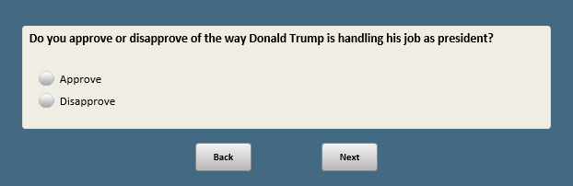

Base: POL1DT=1 or 2 (ASK IF ANSWERED POL1DT)

**POL1DTSTR [S]**

Do you **[IF POL1DT=1:** approve**; IF POL1DT=2:** disapprove**]** of the way Donald Trump is handling his job as president…

1 Very strongly

2 Not so strongly

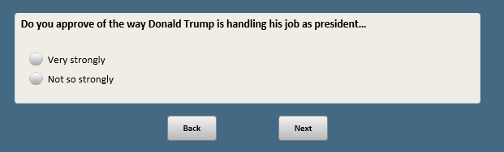

Base: ASK IF (POL1DT=1 or 2) and xform=1

**DTCNCRN [O]**

**[IF POL1DT=1:** And while you approve of the job Donald Trump is doing, what**] [IF POL1DT=2:** What**]**, if anything, concerns you most about how Trump is handling his job as president?

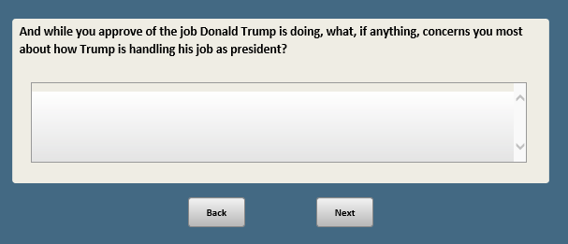

Base: ASK IF (POL1DT = 1 or 2) and xform=2

**DTLIKE [O]**

**[IF POL1DT=2:** And while you disapprove of the job Donald Trump is doing, what**][IF POL1DT=1:** What**]**, if anything, do you like most about how Trump is handling his job as president?

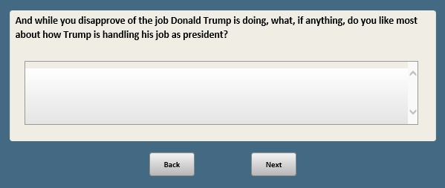

BASE: ASK ALL

**OFTVOTE [S]**

How often would you say you vote?

1 Always

2 Nearly always

3 Part of the time

4 Seldom

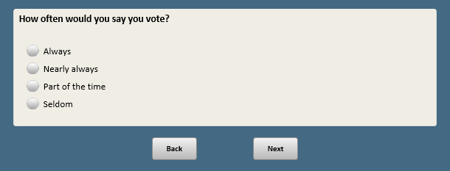

BASE: ASK ALL

*PROGRAMMING NOTE: PLEASE FLIP THE LABELS FOR HALF OF RESPONDENTS LEAVING THE SCALE ALWAYS 1🡪4; CAPTURE RANDOMIZATION*

**MATTERSCONG [S]**

Thinking about how you feel about the 2018 congressional election, where would you place yourself on the following scale?

1 = Really matters which party wins control of Congress

2

3

4 = Doesn’t really matter which party wins control of Congress

**~~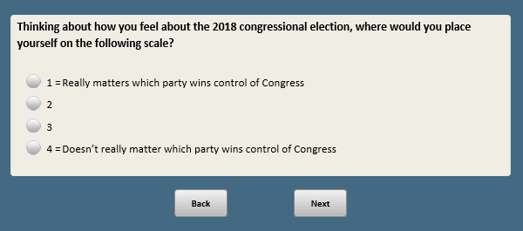~~**

Base: F_STATE_FINAL NE 11

*Scripter: Randomize and record responses 1 and 2*

**CONG [S]**

If the elections for the U.S. House of Representatives were being held TODAY, would you vote for…

1 The Republican Party’s candidate in your district

2 The Democratic Party’s candidate in your district

3 Another candidate **[anchor]**

4 Not sure **[anchor]**

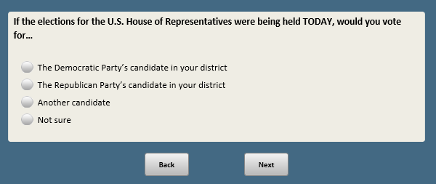

Base: (CONG=4 or refused)

*Scripter: Show in same order as CONG*

**CONGA [S]**

As of TODAY, do you lean more to…

1 The Republican Party’s candidate in your district

2 The Democratic Party’s candidate in your district

3 Lean to another candidate

4 Not sure

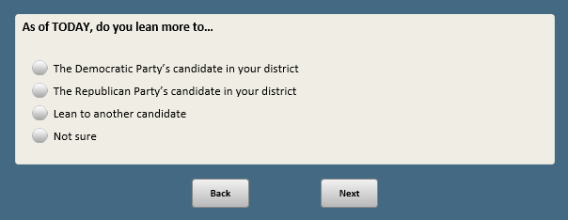

Base: xform=1 or 2 or 3

*Scripter: Randomize and record order of items a-h*

*Soft prompt if skipped: “If you’re sure you want to skip, click Next.”*

**NEWS_PLATFORM [S]**

Now, thinking about your news habits…

How often do you…

a. Read any newspapers in print?

* 1. Often
  2. Sometimes
  3. Hardly ever
  4. Never

b. Listen to news on the radio?

1. Often
2. Sometimes
3. Hardly ever
4. Never

**NO ITEM C**

d. Watch local television news?

1. Often
2. Sometimes
3. Hardly ever
4. Never

e. Watch national evening network television news (such as ABC World News, CBS Evening News, or NBC Nightly News)?

1. Often
2. Sometimes
3. Hardly ever
4. Never

f. Watch cable television news (such as CNN, The Fox News cable channel, or MSNBC)?

1. Often
2. Sometimes
3. Hardly ever
4. Never

g. Get news from a social media site (such as Facebook, Twitter or Snapchat)?

1. Often
2. Sometimes
3. Hardly ever
4. Never

h. Get news from a news website or app?

1. Often
2. Sometimes
3. Hardly ever
4. Never

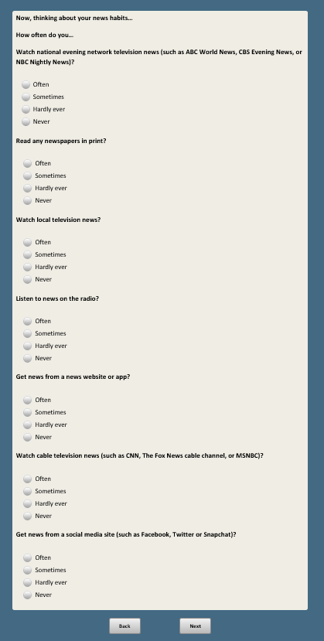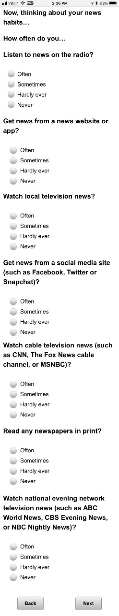

Base: (NEWS_PLATFORMa-h=1-3). DO NOT ASK IF ONLY GETS NEWS ON TV AND NO OTHERS (IF ONLY NEWS_PLATFORMd-f=1-3, and no other selections).

*SHOW THOSE THAT WERE AT LEAST “HARDLY EVER” IN NEWS_PLATFORM NEWS_PLATFORMa-h=1-3); SHOW “Watch news on television” if NEWS_PLATFORMd=1-3 OR NEWS_PLATFORMe=1-3 OR NEWS_PLATFORMf=1-3*

*If only one option selected in NEWS_PLATFORM, autopunch here and do not show respondent this question. If only selected the television items NEWSPLATFORMd-f and no other platform, skip question and autopunch into NEWS_PREFER=3*

*Scripter: Show in same order as NEWS_PLATFORM*

**NEWS_PREFER [S]**

Which of the following would you say you prefer for getting news?

1. Reading news in a print newspaper
2. Listening to news on the radio
3. Watching news on television
4. Getting news from a social media site (such as Facebook, Twitter or Snapchat)
5. Getting news from a news website or app

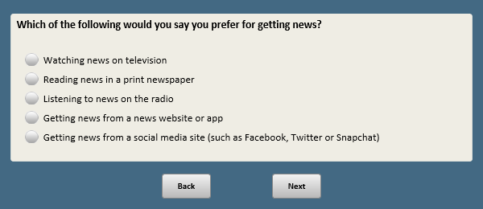

Base: xform=1 or 2 or 3

**STREAMNEWS [S]**

How often do you watch news on a TV using a streaming device (such as Roku, Apple TV, or a gaming console)?

1. Often
2. Sometimes
3. Hardly ever
4. Never

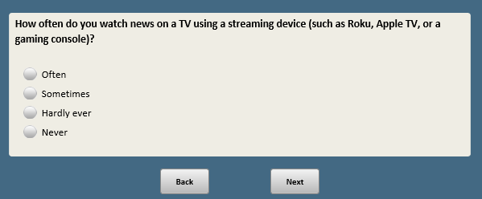

Base: xform=4

*Scripter: Randomize and record order of items a-e*

*Soft prompt: “If you’re sure you want to skip, click Next.”*

**NEWS_PLATFORM2 [S]**

Now, thinking about your news habits…

How often do you get news…

a. From a print newspaper

1. Often
2. Sometimes
3. Hardly ever
4. Never

b. On the radio

1. Often
2. Sometimes
3. Hardly ever
4. Never

c. On a television (whether through broadcast and cable TV or streaming devices such as Roku, Apple TV, or a gaming console)

1. Often
2. Sometimes
3. Hardly ever
4. Never

d. Online, from a social media site (such as Facebook, Twitter or Snapchat)

1. Often
2. Sometimes
3. Hardly ever
4. Never

e. Online, from a news website or app

1. Often
2. Sometimes
3. Hardly ever
4. Never

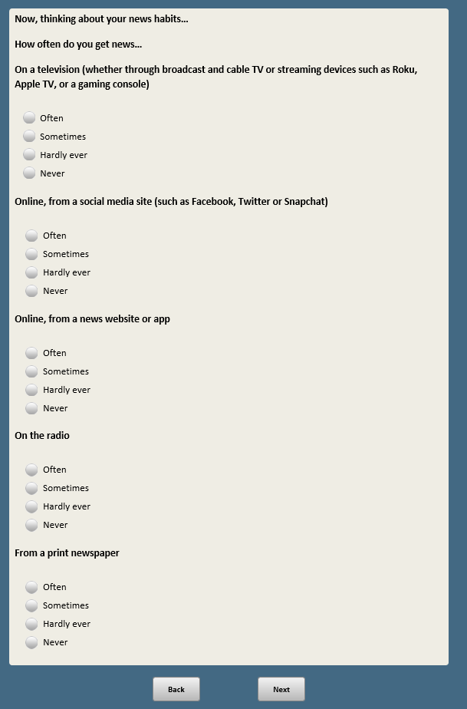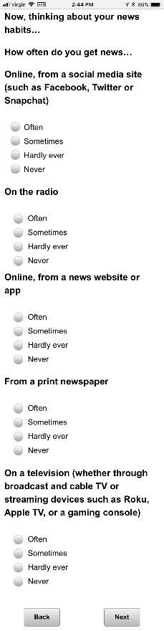

Base: xform=4

*Scripter: Randomize and record order of items a-c*

*Soft prompt: “If you’re sure you want to skip, click Next.”*

**TVNEWS [S]**

And how often do you get news…

a. From local television news

1. Often
2. Sometimes
3. Hardly ever
4. Never

b. From national evening network television news (such as ABC World News, CBS Evening News, or NBC Nightly News)

1. Often
2. Sometimes
3. Hardly ever
4. Never

c. From cable television news (such as CNN, The Fox News cable channel, or MSNBC)

1. Often
2. Sometimes
3. Hardly ever
4. Never

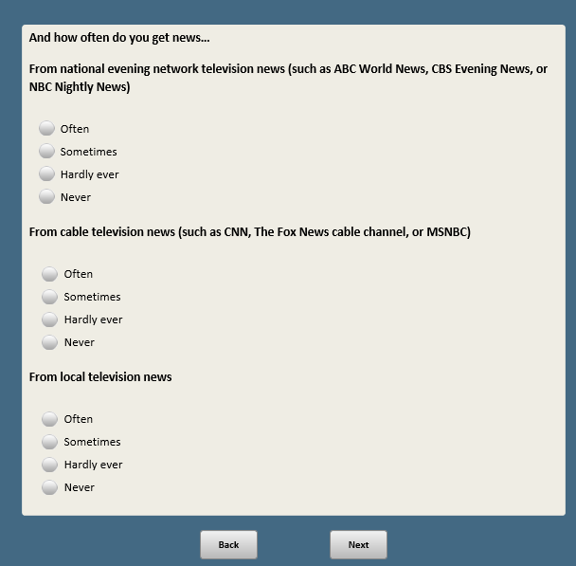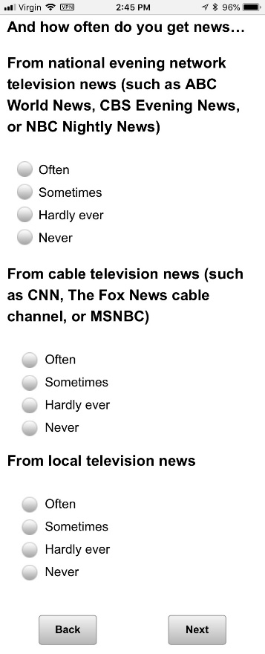

Base: (NEWS_PLATFORM2a-e=1-3)

*Scripter: Show those that were at least “Hardly Ever” in NEWS_PLATFORM2*

*Show in same order as NEWS_PLATFORM2*

*If only one option selection selected in NEWS_PLATFORM2, autopunch here and do not show respondent this question.*

**NEWS_PREFER2 [S]**

Which of the following would you say you prefer for getting news?

1. A print newspaper
2. A radio
3. A television
4. A social media site (such as Facebook, Twitter or Snapchat)

5 A news website or app

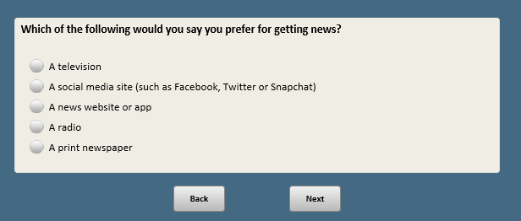

BASE: ASK ALL

*Scripter: Randomize and record response order*

**NEWS_FORM [S]**

Whether online or offline, do you prefer to get your news by…

1. Reading it
2. Watching it
3. Listening to it

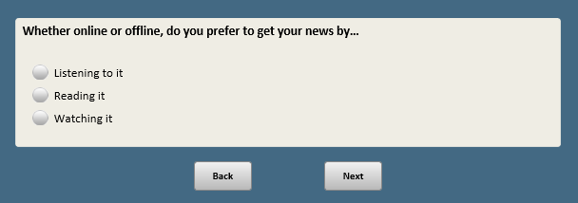

Base: F_INTUSER_FINAL=1 (ASK ALL INTERNET USERS)

*Scripter: Randomize and record responses a-k*

*Soft prompt if skipped: You have not selected any of the sites. If this is correct, click Next.*

*Scripter: Custom prompt if “Other” is selected and nothing in text box:* You did not provide a response in the text box. If you would like to skip, click Next.

**SNS [M]**

Do you use any of the following social media sites?

*[Check all that apply]*

a. Facebook

b. Twitter

**NO ITEM C**

d. LinkedIn

e. Instagram

**NO ITEM F**

g. Tumblr

h. YouTube

i. Reddit

j. Snapchat

k. WhatsApp

l. Other **[O] [anchor]**

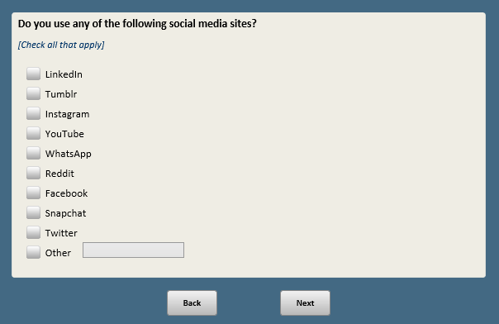

Base: SNSA-K=1 (ASK IF AT LEAST YES TO 1 ITEM SNS)

*Scripter: SHOW ONLY THOSE SITES USED (selected at SNS)*

*Scripter: Show in same order as SNS*

**SNSNEWS [S]**

Do you ever get news or news headlines on any of the following sites? By news we mean information about events and issues that involve more than just your friends or family.

1. Facebook

1 Yes

2 No

b. Twitter

1 Yes

2 No

**NO ITEM C**

d. LinkedIn

1 Yes

2 No

e. Instagram

1 Yes

2 No

**NO ITEM F**

g. Tumblr

1 Yes

2 No

h. YouTube

1 Yes

2 No

i. Reddit

1 Yes

2 No

j. Snapchat

1 Yes

2 No

k. WhatsApp

1 Yes

2 No

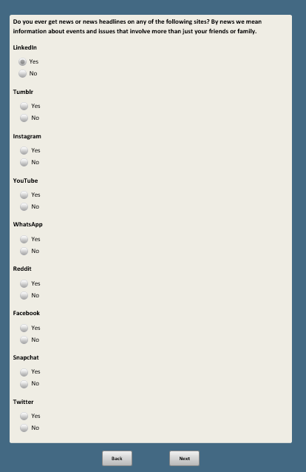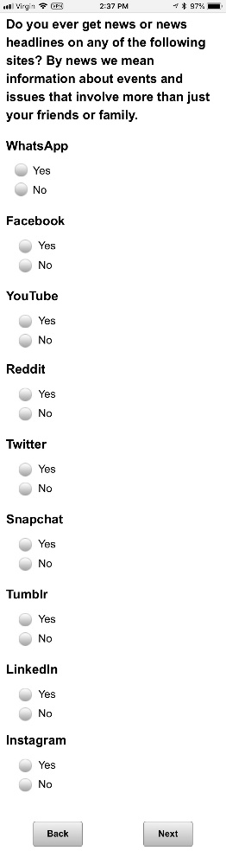

Base: NEWS_PLATFORMg=1-3 or NEWS_PLATFORM2d=1-3 (ASK IF GETS NEWS ON SOCIAL MEDIA)

*Scripter: Allow as many characters as possible (copy format from CHECKMOD)*

**SNSLIKE [O]**

What do you LIKE most about getting news on social media?

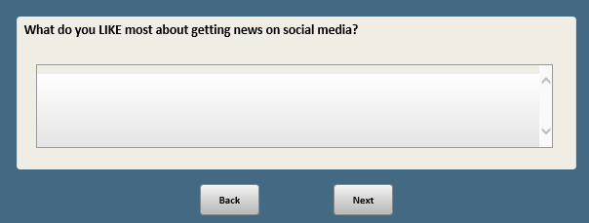

Base: NEWS_PLATFORMg=1-3 or NEWS_PLATFORM2d=1-3 (ASK IF GETS NEWS ON SOCIAL MEDIA)

*Scripter: Allow as many characters as possible (copy format from CHECKMOD)*

**SNSDISLIKE [O]**

What do you DISLIKE most about getting news on social media?

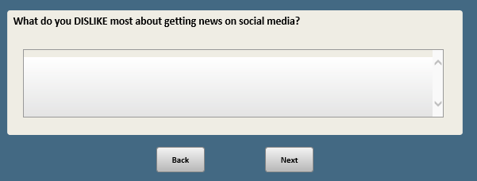

Base: NEWS_PLATFORMg=1-3 or NEWS_PLATFORM2d=1-3 (ASK IF GETS NEWS ON SOCIAL MEDIA)

*Scripter: Randomize and record order of responses 1 and 2*

**SNSINFORM [S]**

Overall, would you say news on social media has…

1. Helped you better understand current events
2. Made you more confused about current events
3. Not made much of a difference **[anchor]**

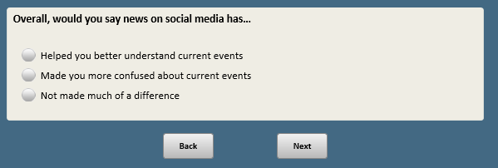

Base: NEWS_PLATFORMg=1-3 or NEWS_PLATFORM2d=1-3 (ASK IF GETS NEWS ON SOCIAL MEDIA)

*Scripter: Randomize and record order of responses*

**SNSSKEP [S]**

Which of the following best describes how you approach news stories from social media sites, even if neither is exactly right?

I expect the news I see on social media will…

1 Largely be accurate

2 Largely be inaccurate

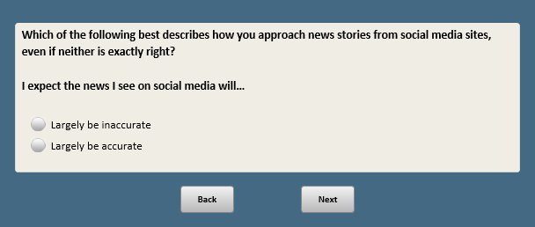

BASE: ASK ALL

**BOTS_HEARD [S]**

Now we’re going to ask you a few questions about social media bots. A social media bot is an account that operates on its own, without human involvement, to post and do other activities on social media sites.

With this in mind, how much have you heard, if anything, about social media bots?

1 A lot

2 Some

3 Not much

4 Nothing at all

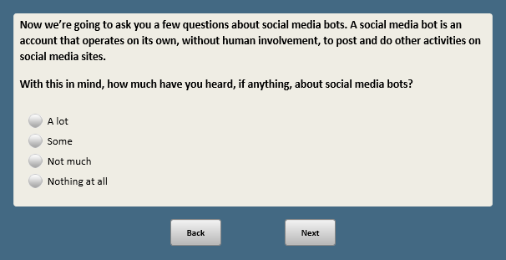

Base: BOTS_HEARD=1-3 (ASK IF HEARD AT LEAST NOT MUCH)

*Scripter: Randomize and record response order*

**BOTS_MORAL [S]**

Based on what you have heard about social media bots, do you think they are mostly…

1 Used for good purposes

2 Used for bad purposes

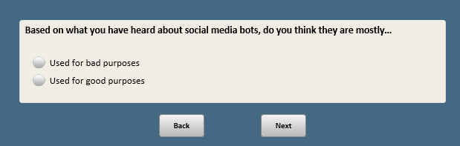

Base: BOTS_HEARD=1-3 (ASK IF HEARD AT LEAST NOT MUCH)

*Scripter: Randomize and record item order within blocks (a-e and f-i)*

*Scripter: Randomize and record block order. Show blocks on separate screens*

*SHOW BLOCK1 and BLOCK2 ON SEPARATE SCREENS; REPEAT STEM FOR SECOND PAGE, WITH “AGAIN,” AT THE BEGINNING; RANDOMIZE ORDER OF BLOCK 1 AND BLOCK 2; RANDOMIZE ITEMS WITHIN EACH BLOCK*

**BOTS_VIGNETTES [S]**

**[on first screen show:**Below aresome possible uses of social media bots. Do you think each of the following uses of bots is acceptable or not acceptable?**]**

**[on second screen show:**Again, below aresome possible uses of social media bots. Do you think each of the following uses of bots is acceptable or not acceptable?**]**

**BLOCK 1**

* 1. A government agency using bots to post emergency updates

1 Acceptable

2 Not acceptable

* 1. An organization or individual using bots to share made-up news or false information

1 Acceptable

2 Not acceptable

* 1. An issue-based group using bots to draw attention to a specific topic

1 Acceptable

2 Not acceptable

* 1. A celebrity using bots to get more followers on social media

1 Acceptable

2 Not acceptable

* 1. A business using bots to promote its products

1 Acceptable

2 Not acceptable

**BLOCK 2**

* 1. A news organization using bots to post headlines or stories

1 Acceptable

2 Not acceptable

* 1. A political party using bots to share information that favors or disfavors one candidate

1 Acceptable

2 Not acceptable

* 1. An individual using bots to share pictures or quotes

1 Acceptable

2 Not acceptable

* 1. A company using bots to respond to customers’ questions

1 Acceptable

2 Not acceptable

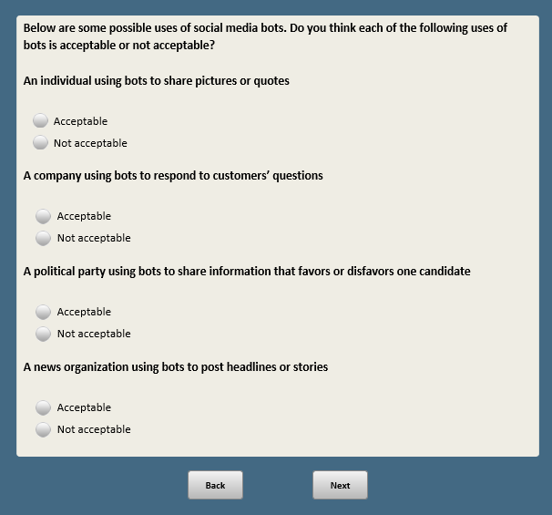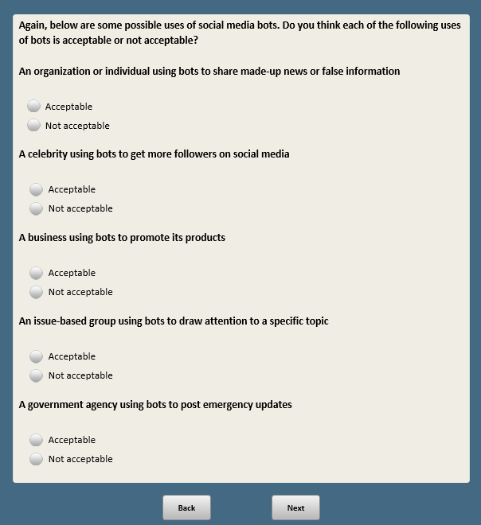

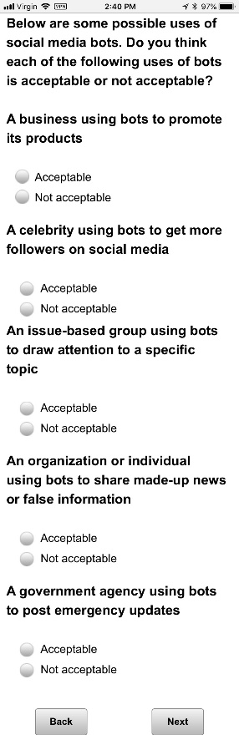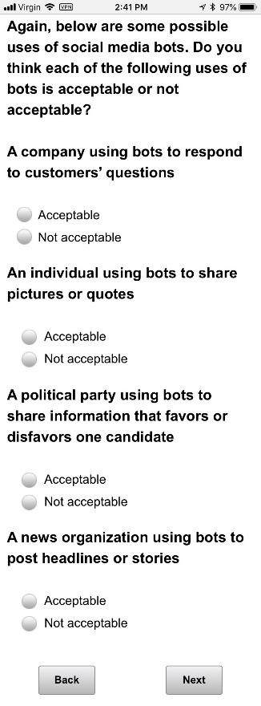

Base: BOTS_HEARD=1-3 (ASK IF HEARD AT LEAST NOT MUCH)

**BOTS_IDENTIFY [S]**

How confident are you in your ability to identify whether a post on social media comes from a bot?

1 Very confident

2 Somewhat confident

3 Not very confident

4 Not at all confident

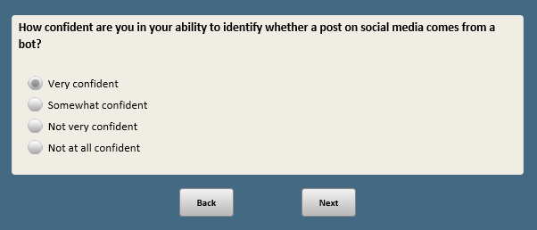

Base: BOTS_HEARD=1-3 (ASK IF HEARD AT LEAST NOT MUCH)

**BOTS_NEWS [S]**

Of all the news that Americans get from social media sites, how much do you think gets to them from bots?

1 A great deal

2 A fair amount

3 Not much

4 None at all

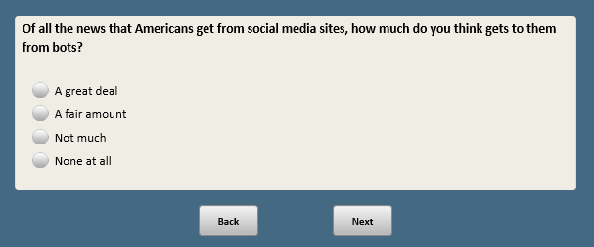

Base: BOTS_HEARD=1-3 (ASK IF HEARD AT LEAST NOT MUCH)

*Scripter: Randomize and record order of responses 1 and 2*

**BOTS_EFFECT [S]**

When it comes to how well informed Americans are about events and issues in the news, would you say that social media bots have had a…

1 Mostly positive effect

2 Mostly negative effect

3 Not much of an effect **[anchor]**

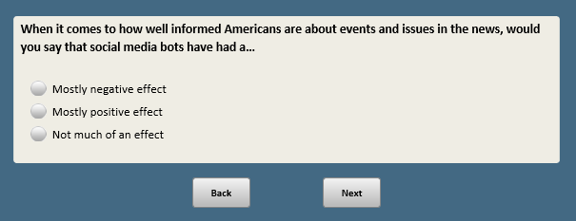

*RANDOMIZE WMNPRZ2 AND WMNPRZ3. RECORD ORDER. DISPLAY INTRO TEXT ONLY IF FIRST QUESTION SHOWN. SHOW ON DIFFERENT SCREENS*

BASE: ASK ALL

*Scripter: Randomly show responses in reverse order, either 1-5 or 5-1. Record order. Show in same order as WMNPRZ3*

*Scripter: Only show “On a different topic…” if question shown first in WMNPRZ2F block*

**WMNPRZ2 [S]**

**[only show if first question shown:** On a different topic…**]**

Do you think it would be a **[show in same order as response list:** (good thing) or a (bad thing)**]** for the country if a Democratic woman was elected president?

1 Very good

2 Somewhat good

3 Neither good nor bad

4 Somewhat bad

5 Very bad

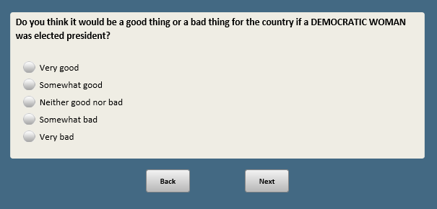

BASE: ASK ALL

*Scripter: Randomly show responses in reverse order, either 1-5 or 5-1. Record order. Show in same order as WMPNPR2*

*Scripter: Only show “On a different topic…” if question shown first in WMNPRZ block*

**WMNPRZ3 [S]**

**[only show if first question shown:** On a different topic…**]**

Do you think it would be a **[show in same order as response list:** (good thing) or a (bad thing)**]** for the country if a Republican woman was elected president?

1 Very good

2 Somewhat good

3 Neither good nor bad

4 Somewhat bad

5 Very bad

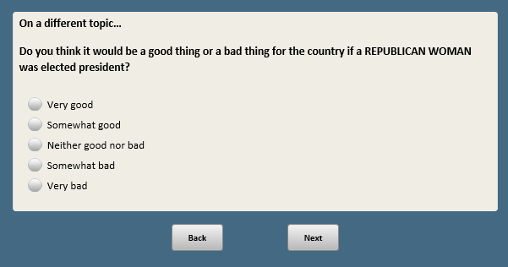

Base: xform=3 or 4

*Scripter: Randomize and record order of items a-e*

**DTADMIN2 [S]**

Since taking office, do you think Donald Trump has done each of the following, or not?

a. Improperly used his office to enrich himself or his friends and family

1 Donald Trump has definitely done this

2 Donald Trump has probably done this

3 Donald Trump has probably NOT done this

4 Donald Trump has definitely NOT done this

b. Run an open and transparent administration

1 Donald Trump has definitely done this

2 Donald Trump has probably done this

3 Donald Trump has probably NOT done this

4 Donald Trump has definitely NOT done this

c. Improved the way government works

1 Donald Trump has definitely done this

2 Donald Trump has probably done this

3 Donald Trump has probably NOT done this

4 Donald Trump has definitely NOT done this

d. Improved the country’s standing around the world

1 Donald Trump has definitely done this

2 Donald Trump has probably done this

3 Donald Trump has probably NOT done this

4 Donald Trump has definitely NOT done this

e. Set a high moral standard for the presidency

1 Donald Trump has definitely done this

2 Donald Trump has probably done this

3 Donald Trump has probably NOT done this

4 Donald Trump has definitely NOT done this

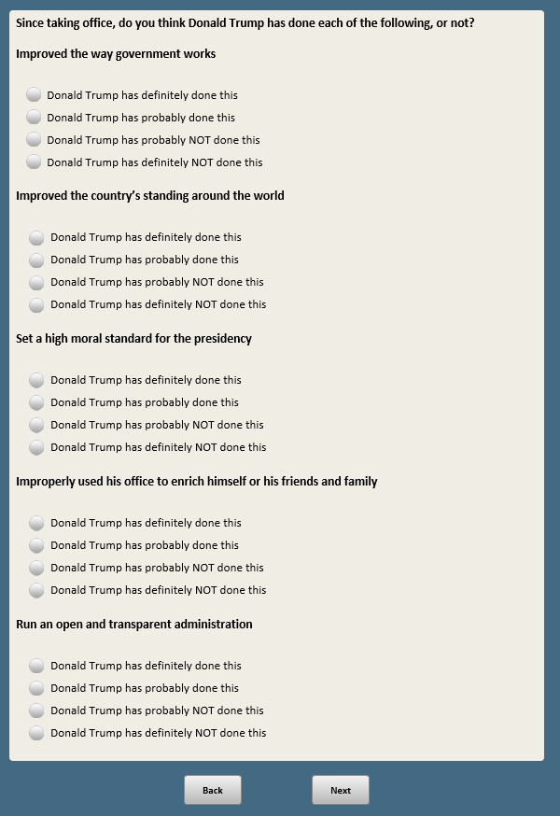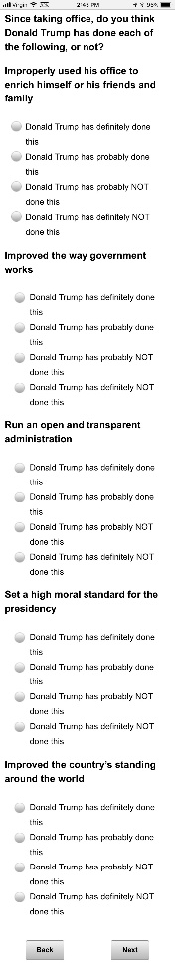

Base: xform=1 or 2

*Scripter: Randomly show reverse order, either 1-5 or 5-1. Record order.*

**DTIDEO [S]**

Which best describes your impression of Donald Trump’s views?

1 He has conservative views on ALMOST ALL issues

2 He has conservative views on MOST issues

3 His views on issues are a mix of conservative and liberal

4 He has liberal views on MOST issues

5 He has liberal views on ALMOST ALL issues

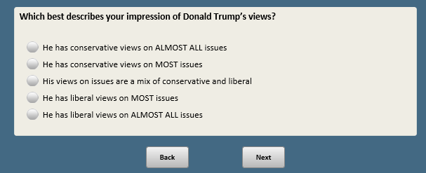

BASE: ASK ALL

*Scripter: Split onto two screens*

*Scripter: Randomize and record order of items a-g*

**CIVIC_ENG_ACTYR [S]**

Here’s a list of activities some people do and others do not. Please indicate if you have done each of the following activities in the past year.

a. Attended a political rally, protest or campaign event

1 Yes, in the past year

2 No, not in the past year

b. Worked or volunteered for a political party, candidate or campaign

1 Yes, in the past year

2 No, not in the past year

c. Contacted any elected official

1 Yes, in the past year

2 No, not in the past year

d. Contributed money to a candidate running for public office or to a group working to elect a candidate

1 Yes, in the past year

2 No, not in the past year

e. Attended government meetings in your community, such as city or town council meetings

1 Yes, in the past year

2 No, not in the past year

**[if xform=1 or 2, show f.F12]**

f.F12 Publicly expressed your support for a candidate, elected official or political campaign on Facebook, Twitter or other social media

1 Yes, in the past year

2 No, not in the past year

**[if xform=3 or 4, show g.F34]**

g.F34 Publicly expressed your opposition to a candidate, elected official or political campaign on Facebook, Twitter or other social media

1 Yes, in the past year

2 No, not in the past year

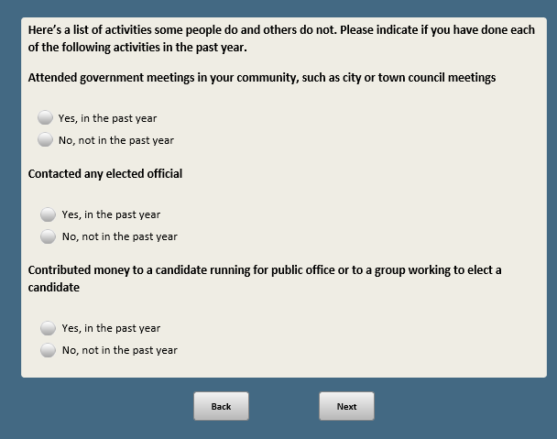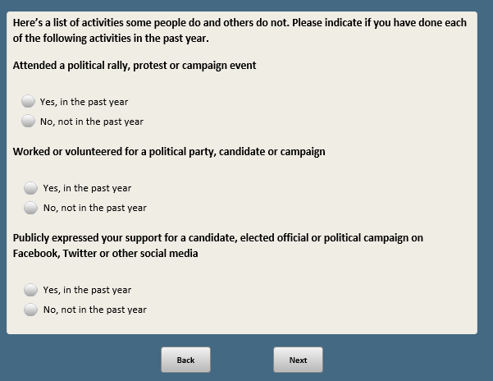

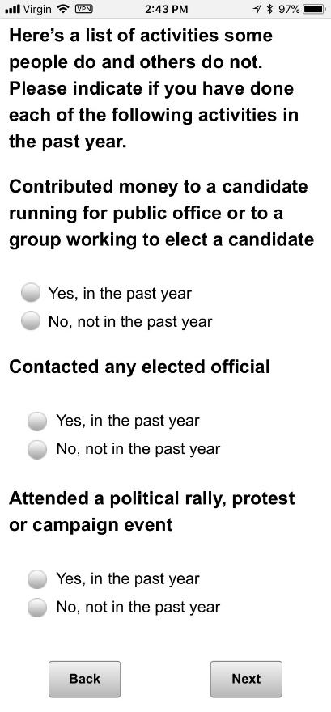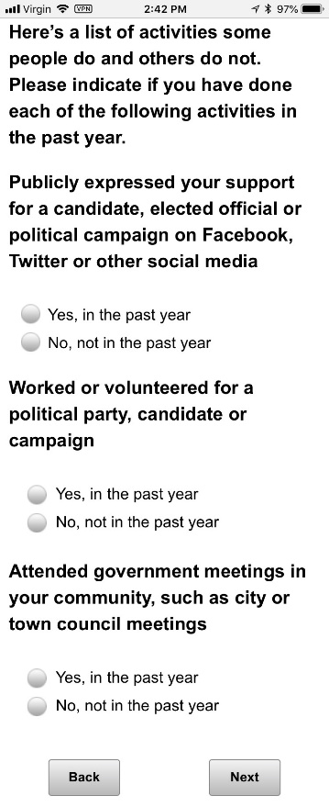

BASE: ASK ALL

*Scripter: Randomize and record response order*

**GLBLECON [S]**

Thinking about the global economy, which comes closer to your view? When other major countries do well economically…

1 It makes it EASIER for the U.S. to do well

2 It makes it HARDER for the U.S. to do well

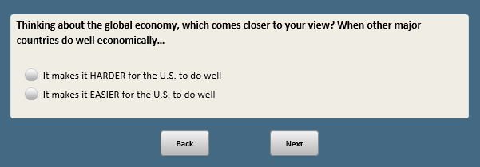

BASE: ASK ALL

*Scripter: Randomize and record responses order*

**TCFACTS2 [S]**

When it comes to important issues facing the country, would you say most Republican voters and Democratic voters…

1          Can agree on the basic facts, even if they often disagree over plans and policies

1. Not only disagree over plans and policies, but also cannot agree on the basic facts

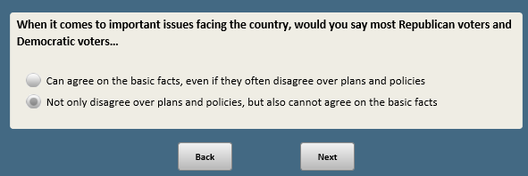

Base: ASK ALL

Scripter: Show as number boxes (do not show thermometer)

Scripter: Randomize and record order of THERMS. Show on same screen.

Add system generated instruction that reads “Enter the number in the box between 0 and 100 that reflects your feelings”

Custom prompt: “Please enter the “degree” or number between 0 and 100 that reflects your feelings in the box. If you would like to skip, click Next.”

**THERMO [Q, range 0-100]**

We'd like to get your feelings toward some different countries in the world on a “feeling thermometer.” A rating of zero degrees means you feel as cold and negative as possible. A rating of 100 degrees means you feel as warm and positive as possible. You would rate the country at 50 degrees if you don’t feel particularly positive or negative toward the country.

*[Enter the number in the box between 0 and 100 that reflects your feelings]*

**[xform=1 or 3] THERMBRITAIN** How do you feel toward Britain?

**[xform=1 or 3] THERMGERMANY** How do you feel toward Germany?

**[xform=1 or 3] THERMIRAN** How do you feel toward Iran?

**[xform=1 or 3] THERMCHINA** How do you feel toward China?

**[xform=1 or 3] THERMINDIA** How do you feel toward India?

**[xform=2 or 4] THERMCANADA** How do you feel toward Canada?

**[xform=2 or 4] THERMJAPAN** How do you feel toward Japan?

**[xform=2 or 4] THERMNKOREA** How do you feel toward North Korea?

**[xform=2 or 4] THERMRUSSIA** How do you feel toward Russia?

**[xform=2 or 4] THERMMEXICO** How do you feel toward Mexico?

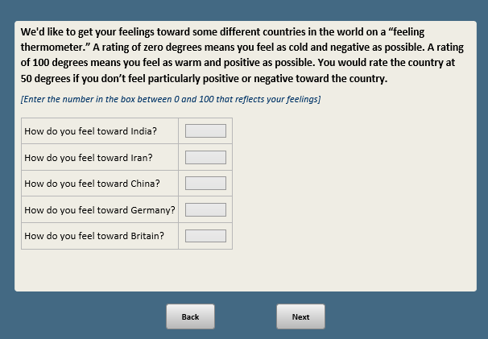

PROGRAMMING NOTE: RANDOMIZE AND RECORD ORDER OF IDEODEM and IDEOREP. SHOW ON SAME LINE FOR FIRST QUESTION ONLY: “In politics, people sometimes talk about liberal and conservative. Where would you place the [IF IDEODEM FIRST: Democratic Party/IF IDEOREP FIRST: rEPUBLICAN PARTY] on a scale from 0 to 10 where 10 means very liberal and 0 means very conservative?”

Base: ASK ALL

*Scripter: RANDOMLY ASSIGN HALF OF RESPONDENTS ‘VERY LIBERAL’ AT THE TOP AND ‘VERY CONSERVATIVE’ AT THE BOTTOM, OTHER HALF SEES THE REVERSE, ALWAYS KEEPING 10 AT THE TOP AND 0 AT THE BOTTOM EACH TIME.*

*Scripter: WHEN THE SCALES CHANGE FOR ½ THE SAMPLE, PER THE NOTE BELOW, THE INTRO LANGUAGE FOR THE FIRST ASK WILL HAVE TO CHANGE AS WELL. THE HALF THAT GET ‘VERY CONSERVATIVE’ AT THE TOP WILL SEE “…WHERE 10 MEANS VERY CONSERVATIVE AND 0 MEANS VERY LIBERAL” IN THE INTRO LANGUAGE. PLEASE KEEP DIRECTION OF LABELING ACROSS THE THREE QUESTIONS THE SAME FOR EACH INDIVIDUAL RESPONDENT.*

**IDEODEM [S]**

**[Please copy the format shown below]**

**[show on the first screen only:** In politics, people sometimes talk about **[show in same order as response labels:** liberal and conservative**]**. Where would you place the **[IF IDEODEM FIRST:** DEMOCRATIC PARTY**/IF IDEOREP FIRST**: REPUBLICAN PARTY**]** on a scale from 0 to 10 where **[show in same order as response labels:** 10 means very liberal and 0 means very conservative**]**? Please click where you would place the **Democratic party** on the scale below.

Very liberal ----- (10)

(9)

(8)

(7)

(6)

----- (5)

(4)

(3)

(2)

(1)

Very conservative ----- (0)

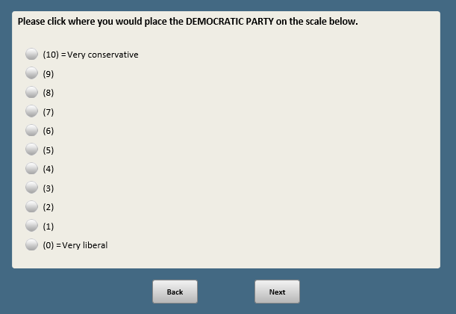

Base: ASK ALL

*Scripter: Show in same order as IDEODEM (or first question)*

**IDEOREP [S]**

**[show on the first screen only:** In politics, people sometimes talk about **[show in same order as response labels:** liberal and conservative**]**. Where would you place the **[IF IDEODEM FIRST:** DEMOCRATIC PARTY**/IF IDEOREP FIRST**: REPUBLICAN PARTY**]** on a scale from 0 to 10 where **[show in same order as response labels:** 10 means very liberal and 0 means very conservative**]**? Please click where you would place the **Republican party** on the scale below.

Very liberal ----- (10)

(9)

(8)

(7)

(6)

----- (5)

(4)

(3)

(2)

(1)

Very conservative ----- (0)

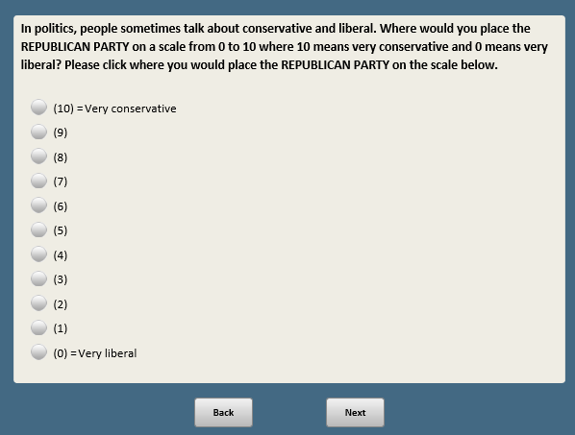

Base: ASK ALL

*Scripter: Show in same order as IDEODEM (or first question)*

**IDEOSELF [S]**

Where would you place **yourself** on this same scale from 0 to 10?

Very liberal ----- (10)

(9)

(8)

(7)

(6)

----- (5)

(4)

(3)

(2)

(1)

Very conservative ----- (0)

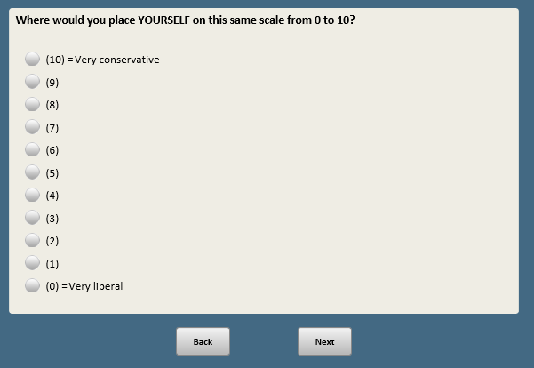

Base: S_ASKMOREKIDS1=1 (ASK WOMEN WHO ARE PARENTS AND ARE AGES 18 TO 49 AND MEN WHO ARE PARENTS AND ARE AGES 18 to 59)

**MOREKIDS1 [S]**

Thinking about the future, how likely is it that you will have more children someday?

1 Very likely

2 Somewhat likely

3 Not too likely

4 Not at all likely

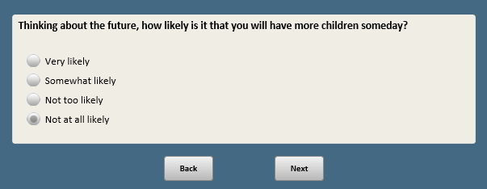

Base: MOREKIDS1=3 or 4 (ASK IF NOT TOO OR NOT AT ALL LIKELY TO HAVE MORE CHILDREN)

*Scripter: Custom prompt if “Other” is selected and nothing in text box:* You did not provide a response in the text box. If you would like to skip, click Next.

**MOREKIDS2 [S]**

Why do you say you are not likely to have more children? Is it because:

1 You just don’t want to have more children

2 Some other reason **[O]**

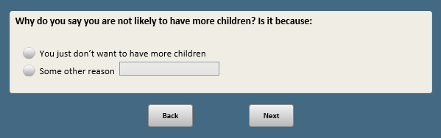

Base: S_ASKHAVEKIDS1=1 (ASK WOMEN WHO ARE NOT PARENTS AND ARE AGES 18 TO 49 AND MEN WHO ARE NOT PARENTS AND ARE AGES 18 to 59)

**HAVEKIDS1 [S]**

Thinking about the future, how likely is it that you will have children someday?

1 Very likely

2 Somewhat likely

3 Not too likely

4 Not at all likely

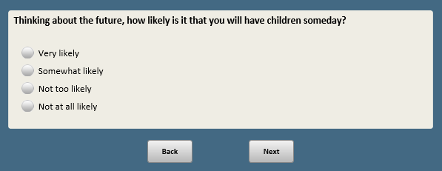

Base: HAVEKIDS1=3 or 4 (ASK IF NOT TOO OR NOT AT ALL LIKELY TO HAVE CHILDREN)

*Scripter: Custom prompt if “Other” is selected and nothing in text box:* You did not provide a response in the text box. If you would like to skip, click Next.

**HAVEKIDS2 [S]**

Why do you say you are not likely to have children? Is it because:

1 You just don’t want to have children

2 Some other reason **[O]**

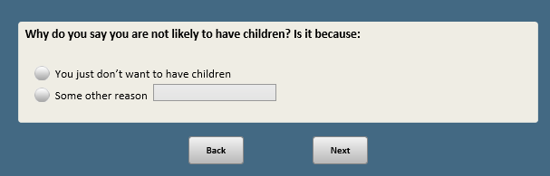

Base: xform=1 or 2

*Scripter: Randomize and record order of items a-f*

*Scripter: If item g selected, unselect all other items*

**VICTIM_SA [M]**

Which of the following, if any, have happened to you, personally?

*[Check all that apply]*

a. Had your wallet or purse stolen

b. Had your identity stolen

c. Were asked to pay a bribe

d. Denied coverage by a health insurance company

e. Over-charged by a mechanic or home repairman

f. Had a home break-in

**[SPACE]**

g. None of these **[S] [anchor]**

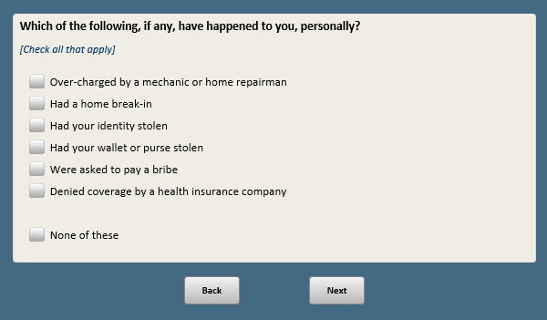

Base: xform=3 or 4

*Sripter: Split onto two screens*

*Scripter: Randomize and record order of items a-f*

**VICTIM_FC [S]**

Which of the following, if any, have happened to you, personally?

1. Had your wallet or purse stolen

1 Yes, has happened to me

2 No, has not happened to me

1. Had your identity stolen

1 Yes, has happened to me

2 No, has not happened to me

1. Were asked to pay a bribe

1 Yes, has happened to me

2 No, has not happened to me

1. Denied coverage by a health insurance company

1 Yes, has happened to me

2 No, has not happened to me

1. Over-charged by a mechanic or home repairman

1 Yes, has happened to me

2 No, has not happened to me

1. Had a home break-in

1 Yes, has happened to me

2 No, has not happened to me

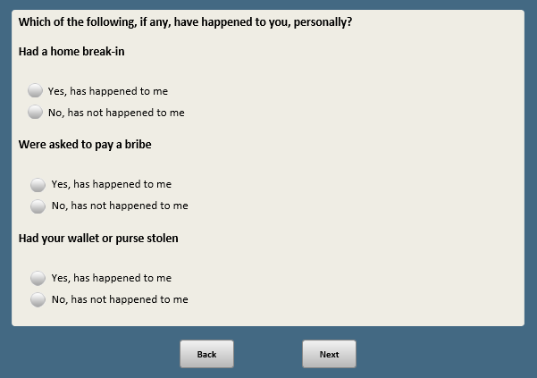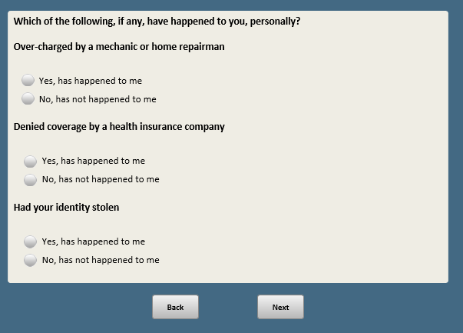



BASE: ASK ALL

**BANK_HACK [S]**

How confident are you that the electronic records of people’s bank accounts and investment activities are safe from hacking?

1 Very confident

2 Somewhat confident

3 Not too confident

4 Not at all confident

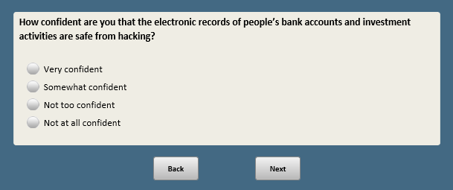

BASE: ASK ALL

**GRID_HACK [S]**

How confident are you that the power grids in the U.S. are protected from cyber attacks?

1 Very confident

2 Somewhat confident

3 Not too confident

4 Not at all confident

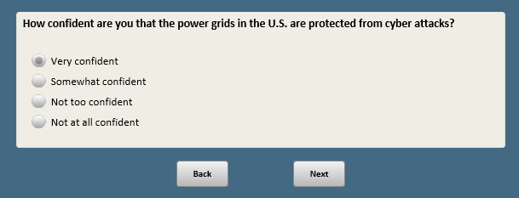

BASE: ASK ALL

*Scripter: Randomize and record response order*

*Scripter: Show on same screen as INSURERS*

**DOCTORS [S]**

Which comes closer to your own view – even if neither is exactly right?

1 Medical doctors almost always make decisions based on a patient’s best interest

2 Medical doctors almost always make decisions aimed at charging more even if that is not in a patient’s best interest

BASE: ASK ALL

*Scripter: Randomize and record response order*

*Scripter: Show on same screen as DOCTORS*

**INSURERS [S]**

Which comes closer to your own view – even if neither is exactly right?

1 Insurance companies generally try to act in the best interest of the policy holder

2 Insurance companies generally are more concerned with making a profit than the policy holder’s best interests

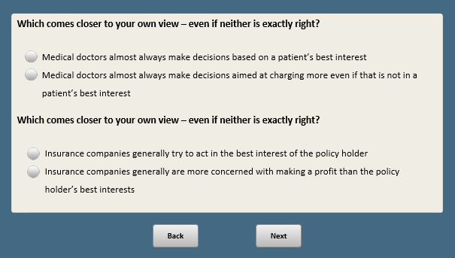

Base: xform=1 or 2

*Scripter: Randomize and record response order*

*Scripter: Show on same screen as POLICE*

**COURTVIEWS1 [S]**

Which comes closer to your own view – even if neither is exactly right?

1 Judges make their rulings based on a neutral reading of the law

2 Judges make their rulings based on their personal political views

Base: xform=3 or 4

*Scripter: Randomize and record response order*

*Scripter: Show on same screen as POLICE*

**COURTVIEWS2 [S]**

Which comes closer to your own view – even if neither is exactly right?

1 The Supreme Court justices make their rulings based on a neutral reading of the Constitution

2 The Supreme Court justices make their rulings based on their personal political views

Base: ASK ALL

*Scripter: Randomize and record response order*

*Scripter: Show on same screen as COURTVIEWS1-2*

**POLICE [S]**

Which comes closer to your own view – even if neither is exactly right?

1 Most police and law enforcement officials treat everyone equally

2 Most police and law enforcement officials are biased against certain groups of people

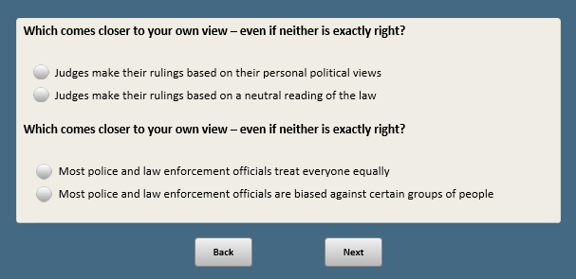

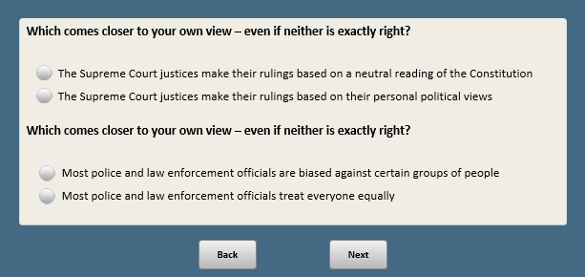

BASE: ASK ALL

*Scripter: Randomize and record response order*

**REPORTERS [S]**

Which comes closer to your own view – even if neither is exactly right?

1 News reporters mainly work for the public interest

2 News reporters mainly work to advance their own interests

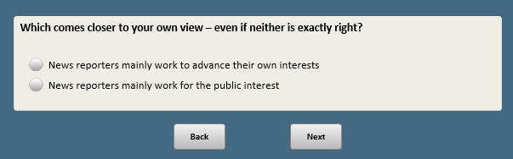

Base: xform=1 or 2

*Scripter: Randomize and record items a-f*

*Scripter: Unselect items a-f if item g is selected*

**FAMTRAD_SA [M]**

Sometimes people are affected by things that happen; not necessarily to themselves, but to people they know.

Which of the following, if any, has happened to you OR someone in your immediate family?

*[Check all that apply]*

1. Lost a job and struggled to find another one
2. Filed for bankruptcy
3. Been treated for addiction to drugs or alcohol
4. Been arrested
5. Lost a home to foreclosure
6. Was seriously injured at work

**[SPACE]**

1. None of these [S] [anchor]

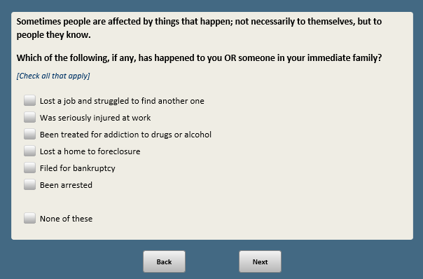

Base: xform=3 or 4

*Scripter: Split onto two screens*

*Scripter: Randomize and record order of items a-f*

**FAMTRAD_FC [S]**

Sometimes people are affected by things that happen; not necessarily to themselves, but to people they know.

Which of the following, if any, has happened to you OR someone in your family?

1. Lost a job and struggled to find another one

1 Yes, has happened to me or my family

2 No, has not happened to me or my family

1. Filed for bankruptcy

1 Yes, has happened to me or my family

2 No, has not happened to me or my family

1. Been treated for addiction to drugs or alcohol

1 Yes, has happened to me or my family

2 No, has not happened to me or my family

1. Been arrested

1 Yes, has happened to me or my family

2 No, has not happened to me or my family

1. Lost a home to foreclosure

1 Yes, has happened to me or my family

2 No, has not happened to me or my family

1. Was seriously injured at work

1 Yes, has happened to me or my family

2 No, has not happened to me or my family

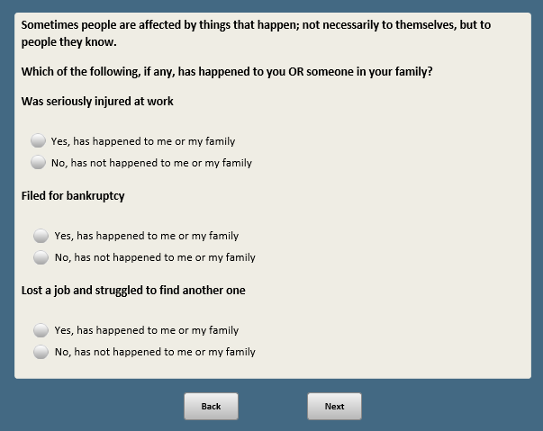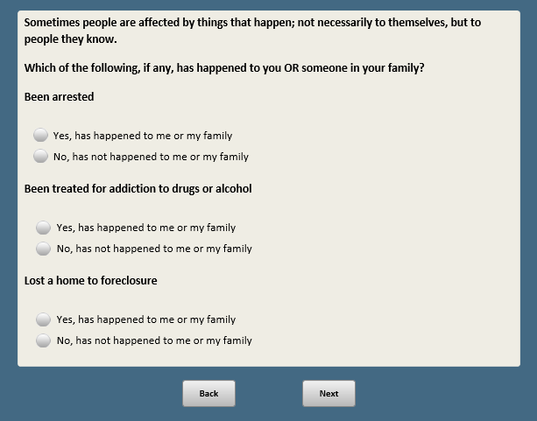

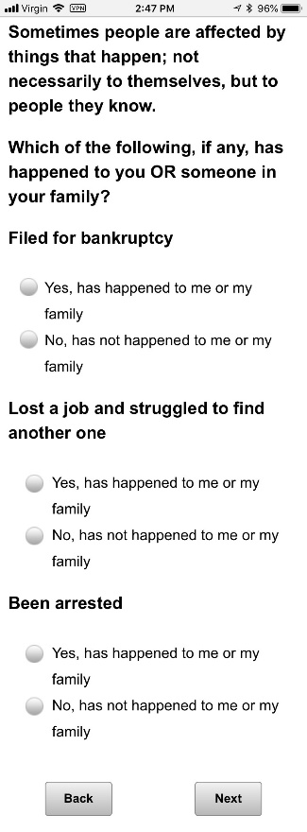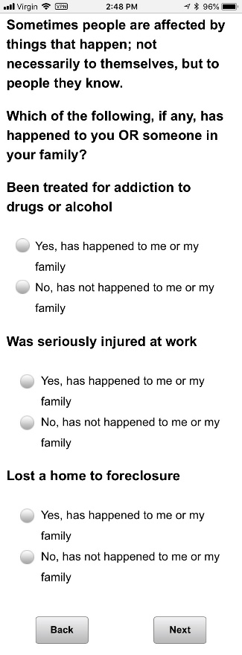

1. Open-end responses are excluded from public datasets to protect the confidentiality of ATP panelists